Requesting Additional Accommodations
Step 1: Log into MinerAccess using your S&T username and password
Step 2: Access the Dashboard
- After logging in, you’ll land on the My Dashboard
- Look for the Accommodations tab on the left side of the screen and click on the Request Additional Accommodations link.

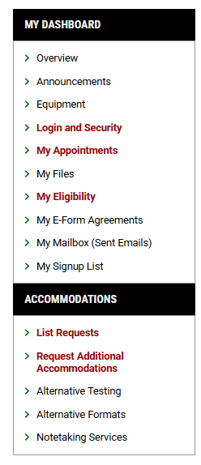

Step 3: Click on the Start New Application button on the Form to request additional accommodations.
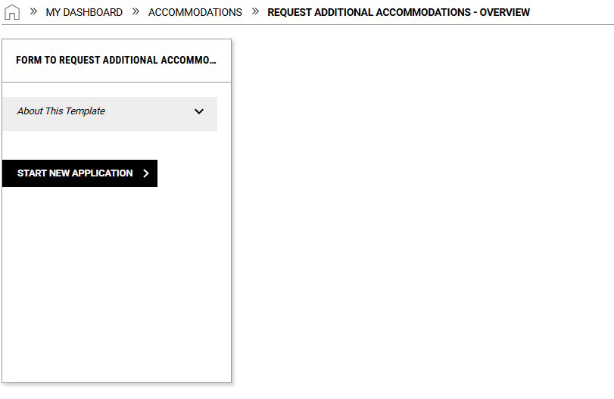
Step 4: Fill out the application and submit the request.
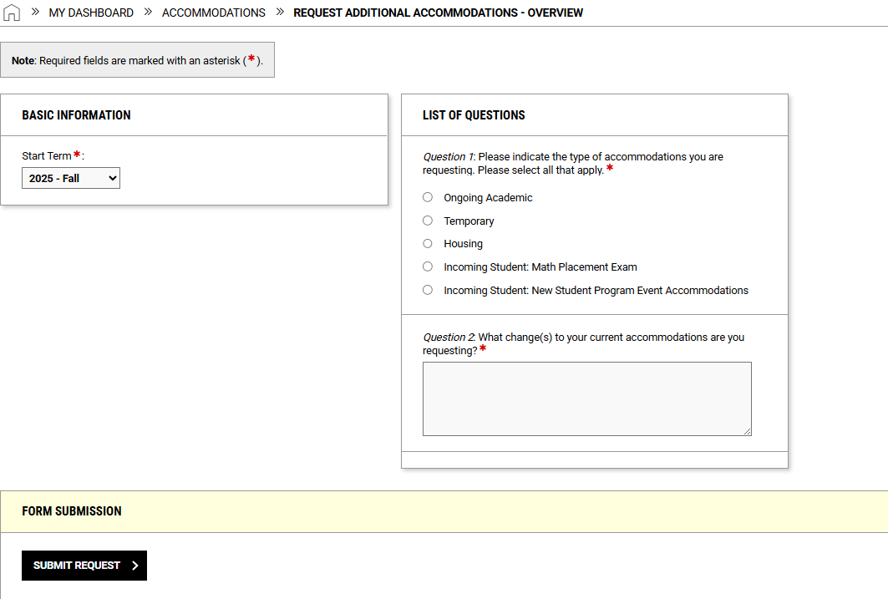
Once you have submitted the application, Student Accessibility and Testing will be in touch to schedule a meeting with an accommodation advisor to review the request.

